# Azure Function App Deployment

* 1. **Creating an Azure Function in Azure**
* Login to <https://portal.azure.com> with account(srv account has to be created) having subscription
* Once logged in, search Function Apps, then click the result under services tab

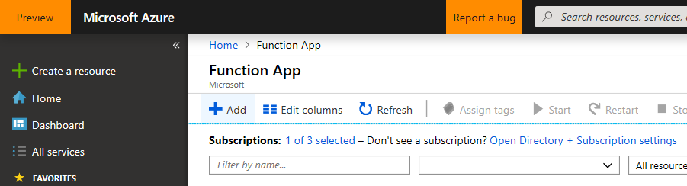

* Click on Add Button to Create a Function App



* Provide App name and other mandatory information as below and make sure Hosting Plan is selected as App Service Plan

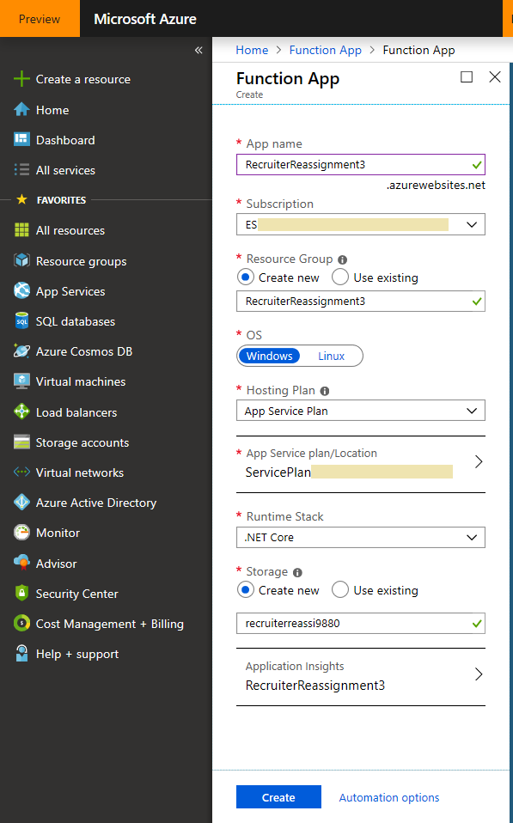

* Click on create Button to create function App.

# Build and publish azure function code

Checkout code from Git hub (<https://github.com/USF-IT/Dynamics-for-USF/tree/crm-dev>)

Open [USF.CRM.Integrations](https://github.com/USF-IT/Dynamics-for-USF/tree/crm-dev/USF.CRM.Integrations) in Visual studio 2017 and build and publish

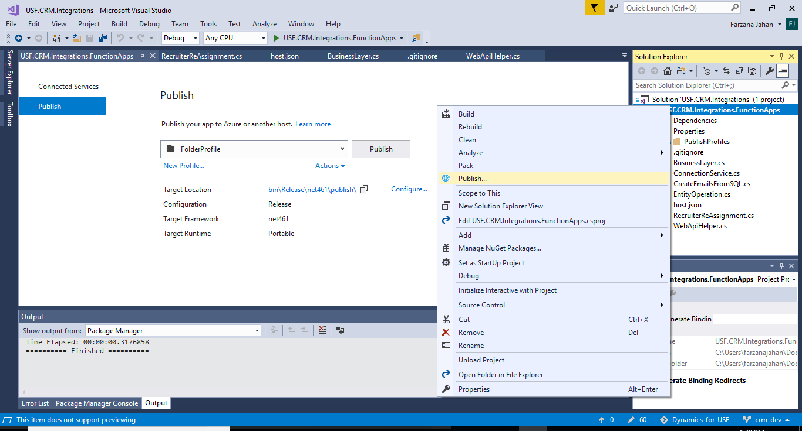

Zip the publish content from USF.CRM.Integrations\USF.CRM.Integrations.FunctionApps\bin\Release\net461\publish\

## Deploy Function App Using ZIP deploy UI

* Open following URL in a new tab.

https://<App- Name>.scm.azurewebsites.net/ZipDeployUI.

Replace <App-Name> with name of App service created.

* In zip deploy screen, Drag and drop zip folder ‘USF.CRM.Integrations.FunctionApps.zip’(downloaded in pre-requisite step) at highlighted folder in screenshot. You can find zip file in deployment folder

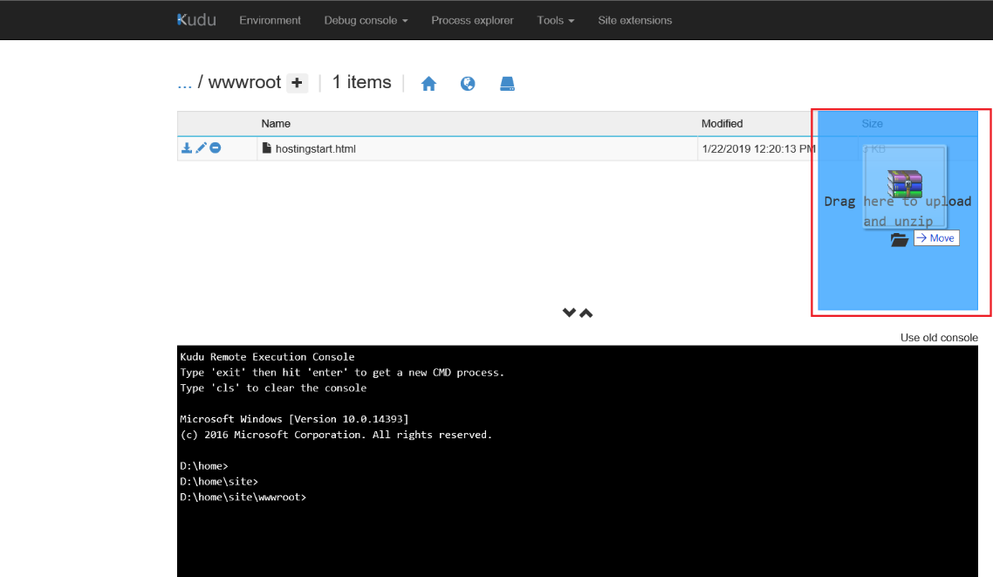

* Once deployment is successful, you will able to see following Files in WWWROOT Folder.

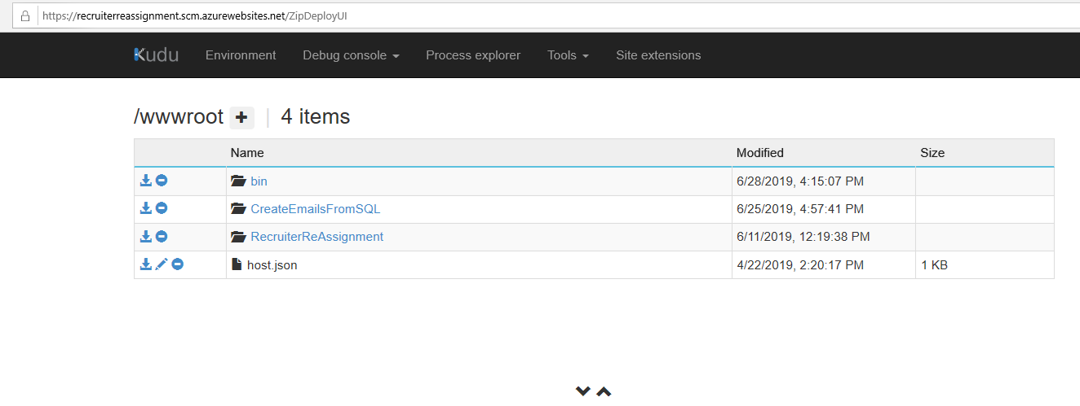

## Create Application User in Dynamics 365

Register app in active directory using the document-

<https://docs.microsoft.com/en-us/dynamics365/customer-engagement/developer/walkthrough-register-dynamics-365-app-azure-active-directory>

<https://docs.microsoft.com/en-us/dynamics365/customer-engagement/developer/walkthrough-register-dynamics-365-app-azure-active-directory>.

Copy application id, tenant id, object id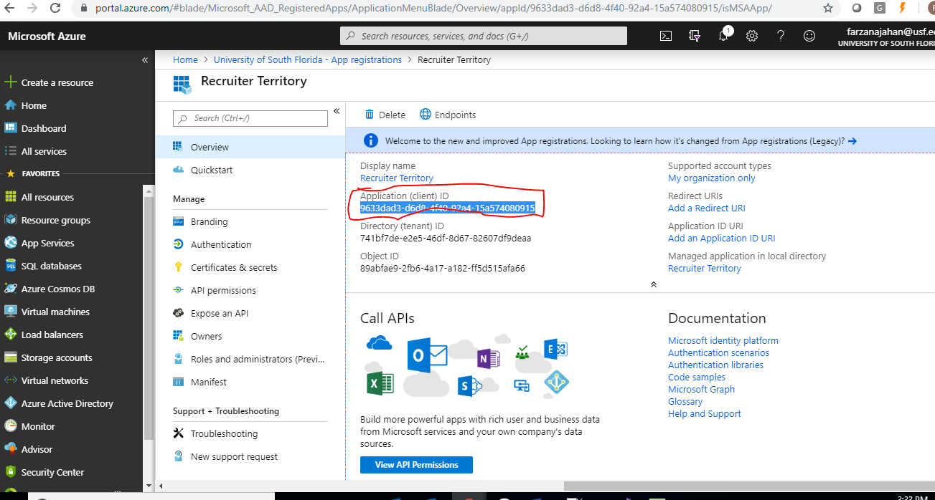

* Login into D365 CE and go to Settings -> Security -> Users

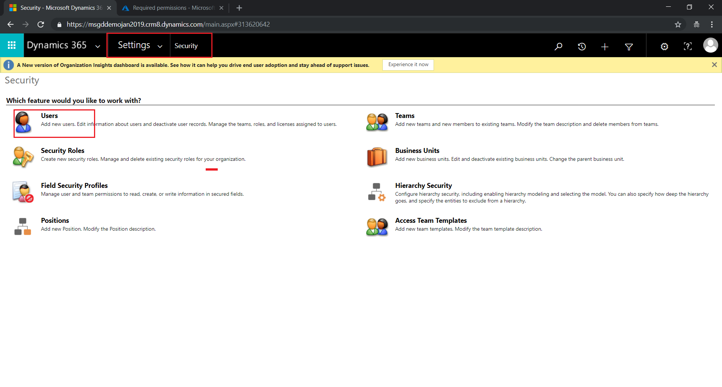

* Change View to “Application User” and Click on New User Button to Create New Application User.

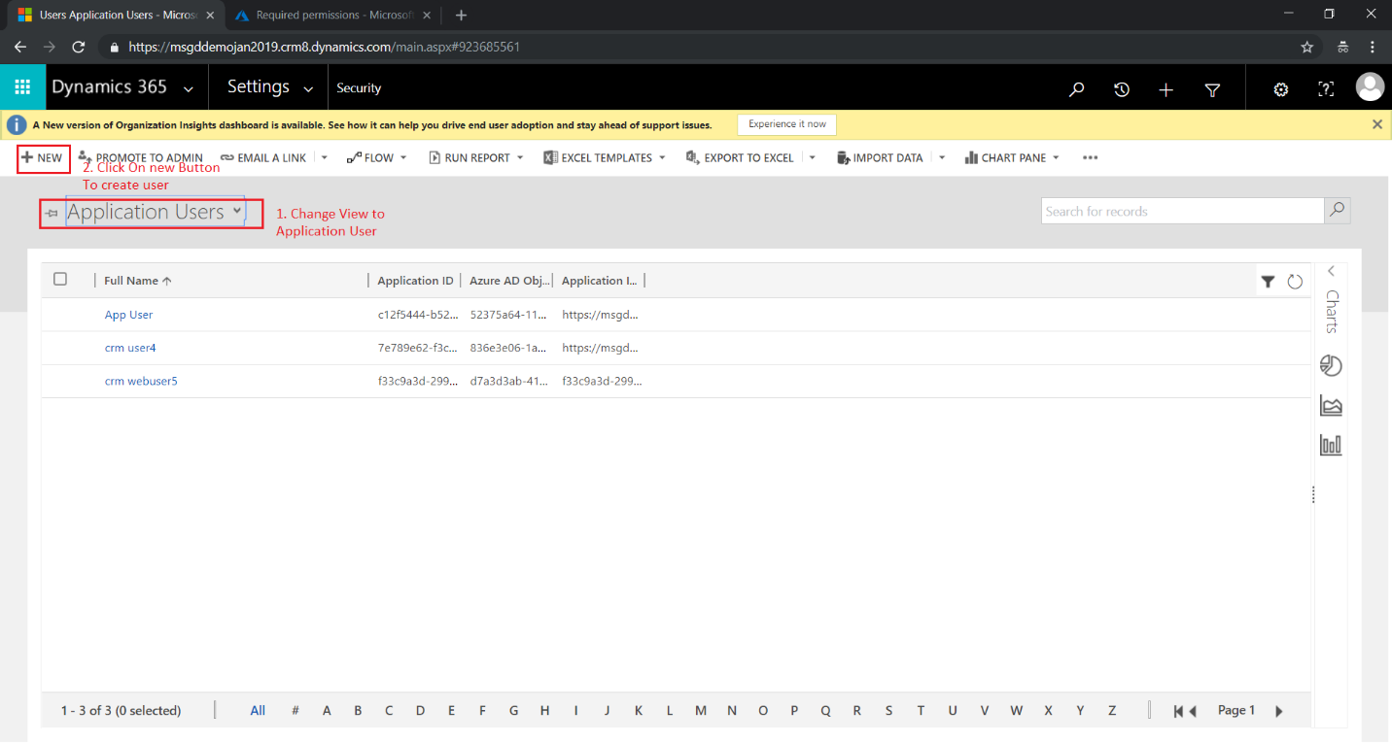

* Enter Username, Application ID – the Application ID which you have already registered in Azure AD for Authentication with Dynamics 365. Full name and Email ID and Save the record.

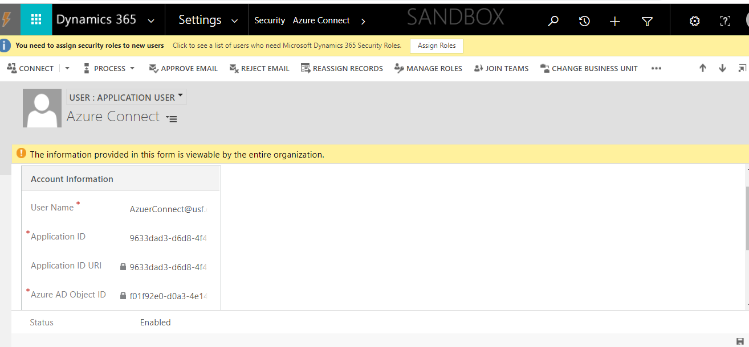

## Assign Appropriate Security Role to the app User

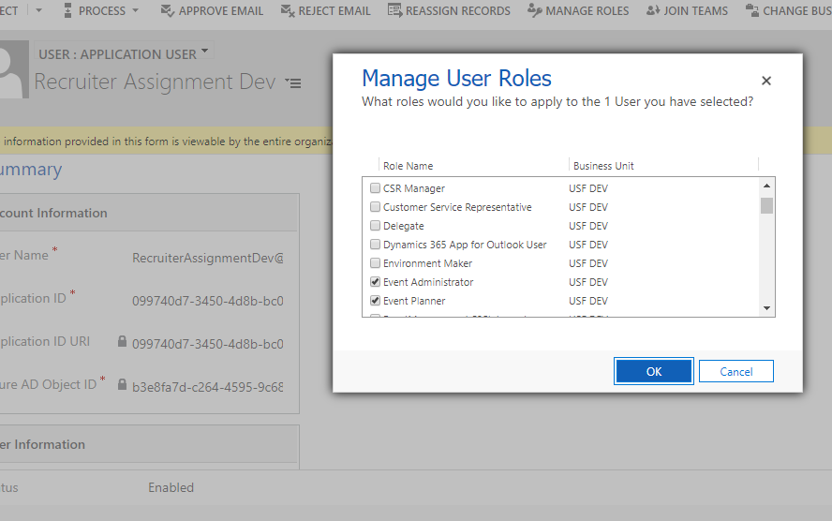

## Generate Application settings value

* Prepare Following Application settings table. This will be handy to update App service Application Settings

|  |  |  |
| --- | --- | --- |
| Key | Sample Value | How to Generate Value |
| crmTokenBaseUrl | https://login.microsoftonline.com/741bf7de-xxxx-46df-xxxx-82607df9deaa/oauth2/token | Copy it from under the endpoints section of your Azure AD app that you have configured for authentication with dynamics |
| crmResourceUrl | https://usfdev.crm.dynamics.com | <Dynamics CRM URL>, https://<Name of CRM Org>.crm.Dynamics.com. This value you can get from web browser CRM URL |
| crmApiUrl | https://usfdev.crm.dynamics.com/api/data/v9.1/ | <Dynamics CRM web API URL>. This Value you can get from, Login into CRM -> Go to -> Settings -> Customization -> Developer Resource -> Instance WEB API, Service Root URL |
| crmAppClientId/Applicationid | 9633dad3-d6d8-4f40-92a4-15a574080915 | This is the Application Id of your Azure AD app that you have configured for authentication with dynamics |
| crmAppSecretId | RZ3i9xxxxXxxxxsXX+**L6M5NQxi | This is the secret of your Azure AD app that you have configured for authentication with dynamics |
| sqlConnectionString | Server=tud-denodo.forest.usf.edu;Port=9996;Username=<<Username>>;Password=<<Password>>;SSL=True;Sslmode=Require;Database=talisma;CommandTimeout=60;Timeout=60 | This is the connection string required for connection with denodo server, replace the server, <<username>>, <<password>> as required per the environment |
| sqlQuery | select * from talisma_email_view limit 5 | This is the sql query for querying resources from denodo |
| sqlTableNameForDS | talisma_email_view | Name of the table/view querying to |
| fromEmail | <<email address>> | This will be the “from” email address when the emails are imported from talisma to dynamics |

## Update Application settings in Azure Function App

* Go to Function Apps -> select your App -> Click on Configurations

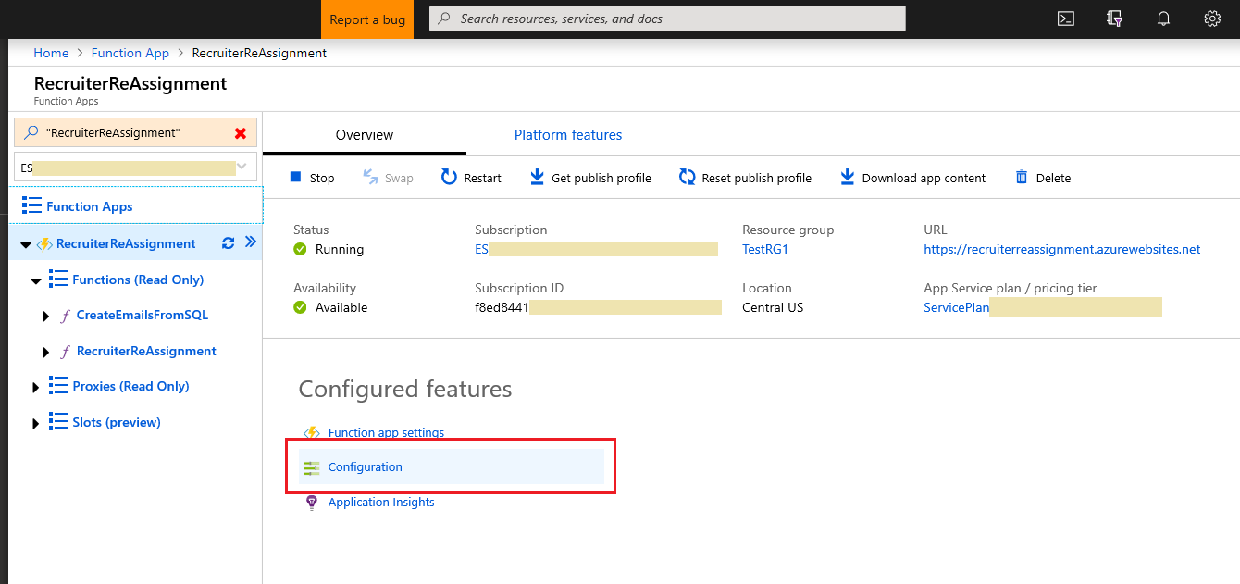

* Click on New application setting and settings as mentioned in step 5.4

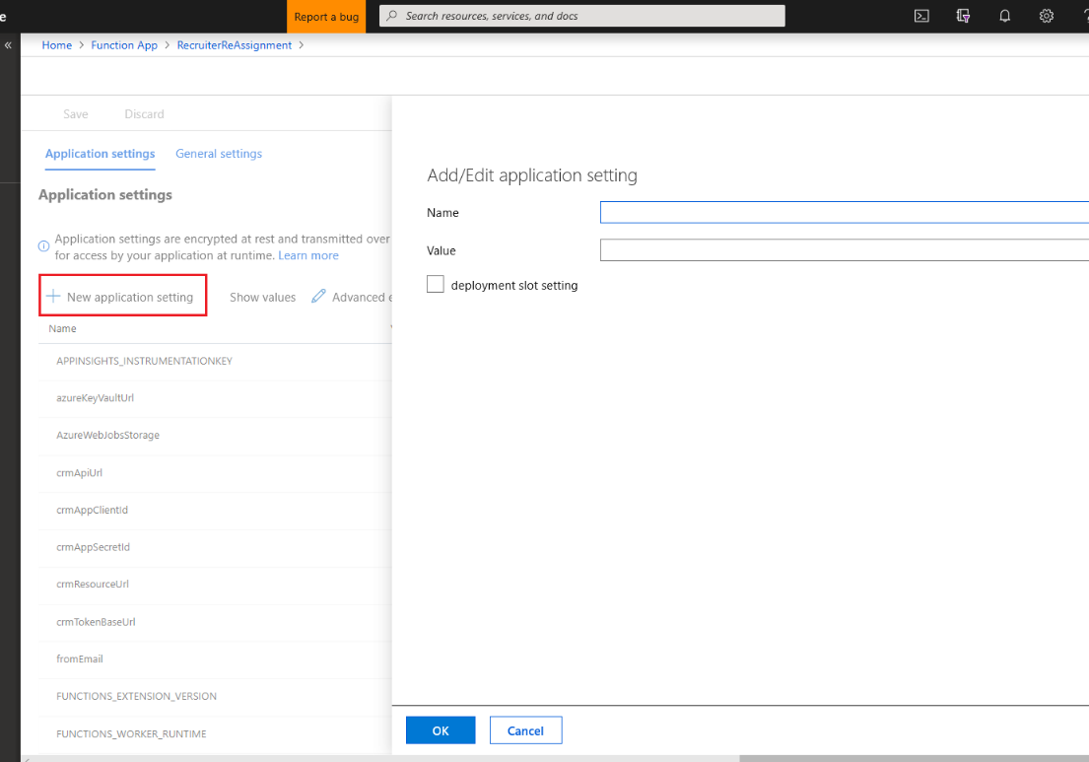

* In application setting, specify Application setting Values. This value will vary as per your azure tenant and CRM Organization. Enter all Application setting value mentioned in step 5.4 and click on **save**.

**Connect Azure function with Dynamics**

Update/create the web hook assembly using the Plugin Registration Tool. Update the web hook setting 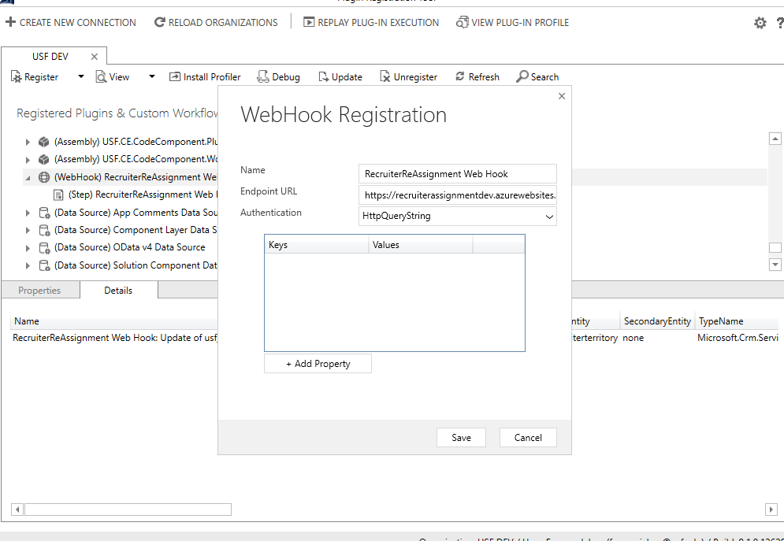

Add/update Sdk message steps to the assembly

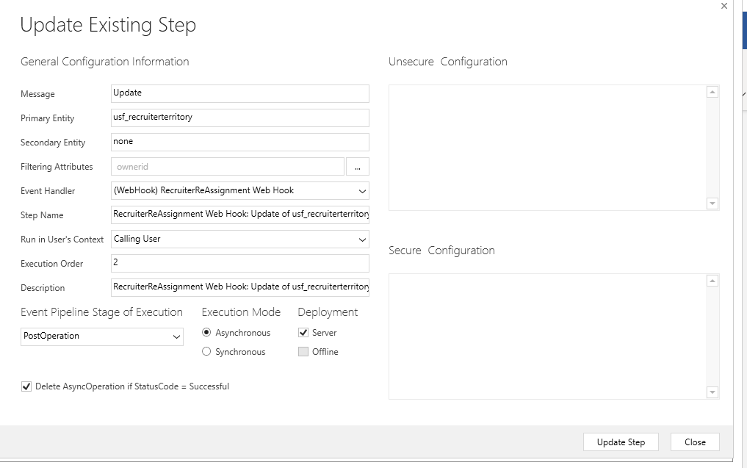

Once webhook is Created Dynamics should be connected to Azure function

Monitoring: